**Fuzzy Logic Inference System for Identification and Prevention of Coronavirus (COVID-19)**

**Aman Sharma,11810810** , LPU

***I. Abstract:*** Nowadays a Novel Coronavirus termed COVID-19 turn out to be foremost health apprehension instigating unembellished health question in human beings and it grow into a plague. It’s a kind of zoonotic that means it can spread animals to humans. It may banquet via dirty hands or metals. No precise treatment is obtainable so far for COVID-19, so initial identification and preventions for COVID-19 will be vital to governor or to break down the shackle of COVID-19. For this resolution, we have wished-for a fuzzy inference system to diagnose the COVID-19 disease by taking three involvement factor like as; Ethanol, Atmospheric Temperature (AT), Body Temperature (BT), and the output factor has divided into three linguistic categories which signifies the brutality level of the disease-ridden patients.

***II. INTRODUCTION:*** Coronavirus is the virus that might root Middle East Respiratory Syndrome (MERS-CoV) and Severe Acute Respiratory Syndrome (SARS-CoV). Subsequently the learning it has been originate that the SARS-CoV was communicated from barren cat to human. Chang et al. [1] shows in his study that the SARS-CoV is a novel virus that may roots the evolving and remerging contamination. Few of the studies [2] & [3] described that SARS-CoV novel virus caused the first pandemic of the paradise. The novel coronavirus called SARS-CoV-2, grounds the disease COVID-19 and has not ever been bump into/found before. It is originated from Wuhan a city of china and till now it effects more than 180 countries and territories. At present many experts and scientists of different republics are deed hard work to invention the fitting vaccine for COVID-19 virus. It effects more than 180 countries and territories, scientists and researchers are not certain about the initiation of COVID-19. COVID-19 is the kind of zoonotic, initially it was communicated from animals to humans [4] & [5] but now it is speedily dispersal from person to person and the binge rate of the contagion growing exponentially, conferring to this theory each diseased individual may contaminate further than 2 folks and each may further contaminate more than 2 and so on. A learning by Harvard T.H. Chan School of Public Health epidemiologist state that virus COVID-19 could taint foremost part of universal inhabitants and affording to the world health organization (WHO) COVID-19 has pretentious more than 31,787,858 people globally with 975,550 death cases till now (by 23-09-2020). In India about 5,646,010 confirmed cases over 4,587,613 patients have well again and about 90,021 have deceased. COVID-19 includes signs like; cough, fever, breathing difficulties besides it may root pneumonia and kidney failure or patient may death, in some cases patient might show no indications at all. Affording to the learning of the Centres for Disease Control and Prevention (CDC) [6] these indications generally seem amid two days and two weeks of contact to the virus. Periodical of the American Medical Association intelligences say that out of all COVID-19 patients 11-44% has fatigue, 76- 82% has coughed and 98% have a fever. The harshness level of the virus growths in the humanoid of age among 28 to 85 years-old. Contemporary research paper has been divided into five sections; in the second section, we have shown the effects of COVID-19 in different types of metal. In the 3rd segment of the investigate paper, we have assumed a review on COVID-19 and in the fourth part section, we have well-defined some fuzzy rules as shown in tab. 3 for the wished-for fuzzy expert system with three inputs as shown in tab. 2 and one output which define the harshness level of the diseased patient as shown in fig. 5. Fifth and last section of the research paper contains deduction part of the work.

***III. Basic Concept:***

**A. Effect of Covid 19 on mental health:** The COVID-19 plague and the subsequent financial collapse have destructively pretentious numerous people’s psychological health and formed new barriers for people already woe from psychological illness and constituent use illnesses. In a KFF Tracking Poll conducted in mid-July, 53% of grownups in the United States stated that their psychological fitness has stayed damagingly wedged owing to concern and anxiety over the coronavirus. This is suggestively higher than the 32% stated in March, the primary time this query was comprised in KFF polling. Numerous grownups are also reportage precise undesirable effects on their psychological health and comfort, such as difficulty snoozing (36%) or consumption (32%), increases in liquor consumption or material use (12%), and falling chronic conditions (12%), due to worry and stress over the coronavirus. As the plague wears on, continuing and essential community fitness dealings depiction numerous folks to facing circumstances allied to unfortunate psychological fitness consequences, such as separation and work damage.[7]

**B.** **Fuzzy Logic in Medical Diagnosis:** Fuzzy logic is a kind of computational model which provided us a precise tool for humanoid cognitive for treatment the numerous kind of doubts. The ability of fuzzy logic delivers us to rapid the humanoid information in linguistic way. The agenda of fuzzy logic used in diverse kind of illness analysis [8, 9, 10] in which the doctors and expert’s knowledge is signified on the behalf of indications and illnesses. In which we can edge the diverse type membership function for the indications contingent upon the drift of the enduring data and they have used to form a appropriate fuzzy expert system.

***IV. A SURVEY ON COVID-19:***

**Chart 1: Spread of Covid 19 in India**

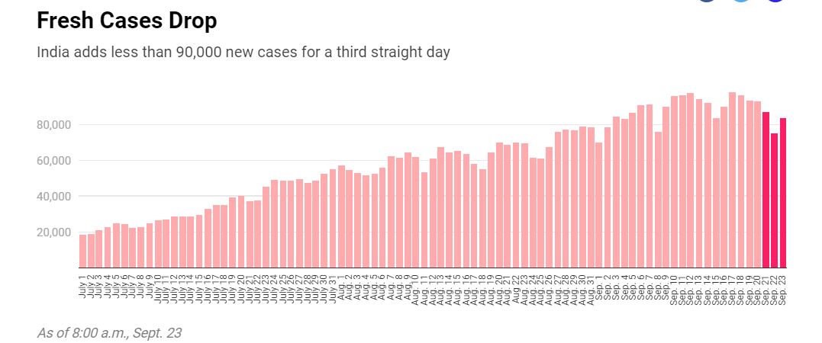

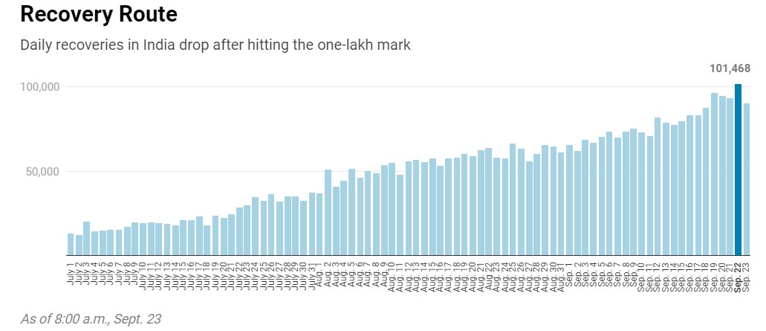

**Chart 2: Total Tests Performed.**

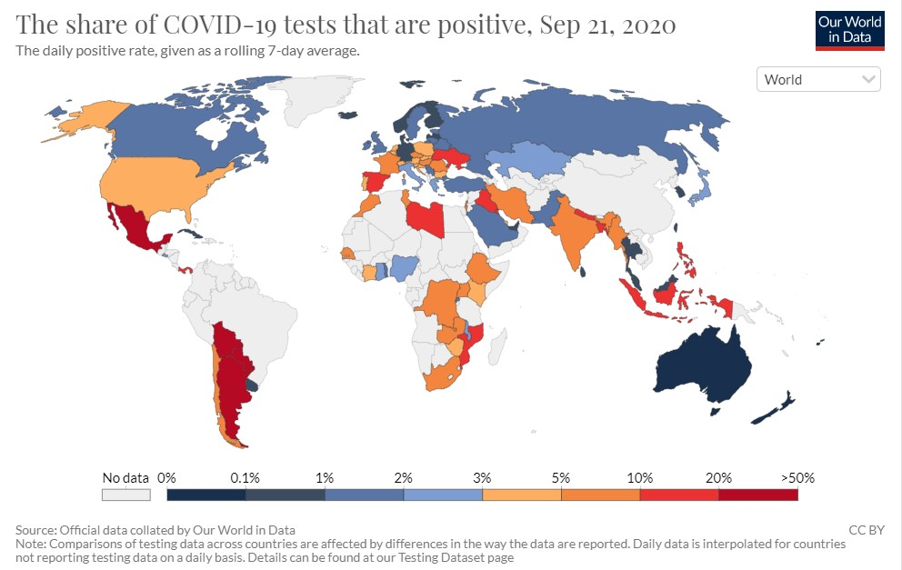

**Chart 3: Weekly Spreading rate.**

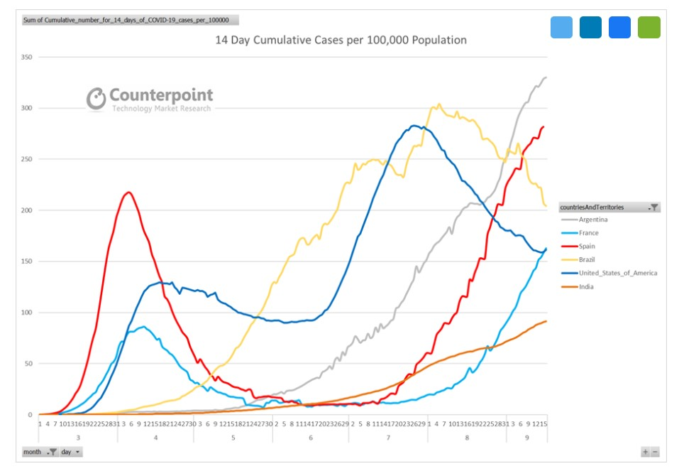

` 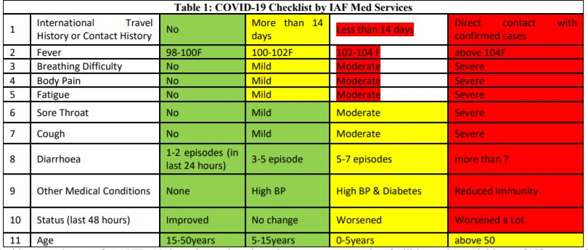

Broadsheet feast degree of COVID-19 has shown by chart 3. amid three different countries. This chart demonstrations that spread rate of COVID-19 increases rapidly in India as associate to other countries. As COVID-19 infections surges in India government newly forms many isolation services at its nodal bases [13] across the country and the explanation given by the various sections of tab. 1 which has divided into three different color section in which green color indicates the Safe Zoon amber indicates Caution Zoon and red indicates Danger Zoon.

**V. Fuzzy INFERENCE SYSTEM:** We have intended a fuzzy inference system (as shown in fig. 1) to identify the COVID-19 virus by captivating three input factors like as; Ethanol, Atmospheric Temperature (AT), Body Temperature (BT), with one output issue which has additional separated into three linguistic groups which denotes the harshness level of the enduring. We will construct membership functions for the included factors. Here, we propose a structure of fuzzy inference system which is based on fuzzy rules for the inference.

|  |  |
| --- | --- |
| **Including Factor** | **Linguistic ranges** |

|  |  |  |  |
| --- | --- | --- | --- |
| Atmospheric  Temperature  (At) | Low ( C ) | Medium | High |
| Ethanol | Low  (mg/dl) | Medium | High |
| Body Temperature  (BT) | Low  (F) | Medium | High |
| Severity | Less severe | Normal | Severe |

**A. Structure of fuzzy interference system.**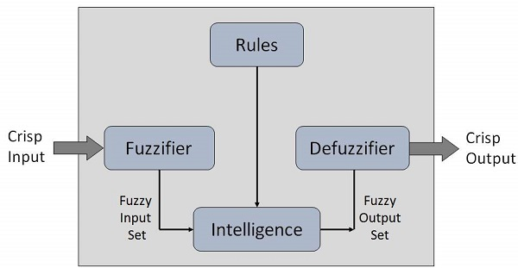

**B. Fuzzy rules for Inference**

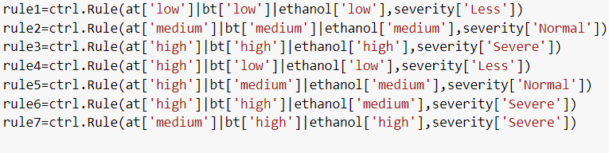

**I. Atmospheric Temp**

at=ctrl.Antecedent(np.arange(0,51,1),'Atmospheric temp')

at['low']=fuzz.trimf(at.universe,[0,0,17])

at['medium']=fuzz.trimf(at.universe,[17,25,35])

at['high']=fuzz.trimf(at.universe,[35,50,50])

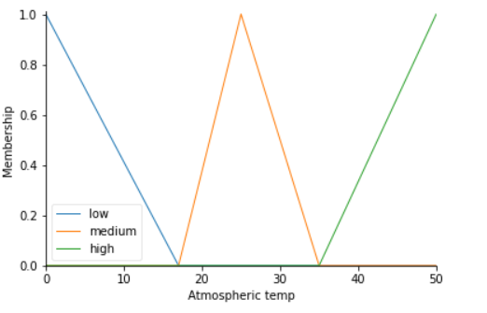

**II. Body Temp**

bt['low']=fuzz.trimf(bt.universe,[30,30,35])

bt['medium']=fuzz.trimf(bt.universe,[35,37,39])

bt['high']=fuzz.trimf(bt.universe,[39,44,44])

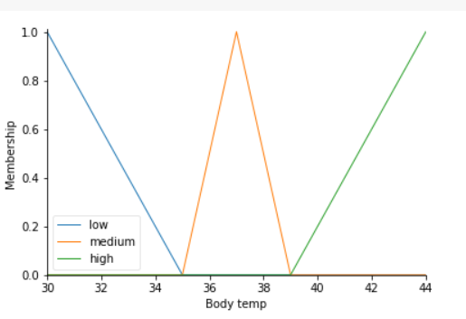

**III. Ethanol**

ethanol=ctrl.Antecedent(np.arange(0,510,10),'ethanol')

ethanol['low']=fuzz.trimf(ethanol.universe,[0,0,100])

ethanol['medium']=fuzz.trimf(ethanol.universe,[100,200,300])

ethanol['high']=fuzz.trimf(ethanol.universe,[300,500,500])

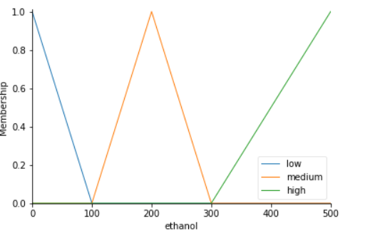

**IV. Severity level for Covid-19**

severity=ctrl.Consequent(np.arange(0,101,1),'severity')

severity['Less']=fuzz.trimf(severity.universe,[0,0,35])

severity['Normal']=fuzz.trimf(severity.universe,[35,52,70])

severity['Severe']=fuzz.trimf(severity.universe,[70,100,100])

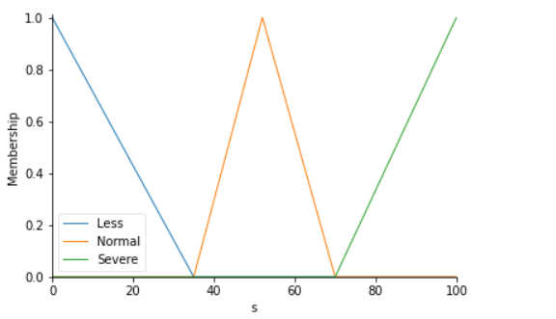

**Output:**

**Less Severity**

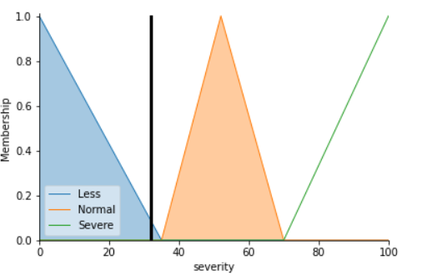

**Normal Severity**

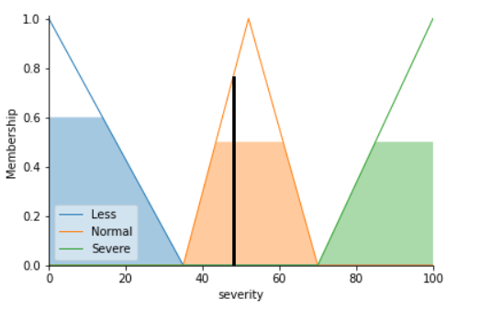

**High Severity**

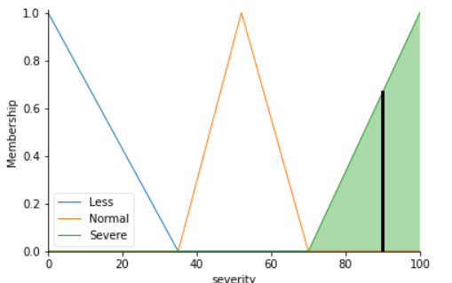

**VI. Conclusion:**

Coronaviruses shortened as CoV covers huge domestic of viruses which reasons basic indications like; cold, cough and fever. Out of these viruses COVID-19 is newly tense that presented in 2019 which has not been recognized before. The implication which we have industrialized in the seek article, we may conclude the following observations;

1) As of tab. 4 we can witness that if the atmospheric temperature is medium, additional intake of ethanol and slightly higher body temperature formerly we will get Usual severity level of infected patient.

2) From tab. 5 if the atmospheric temperature is low, body temperature is high, the intake ethanol quantity then we may detect the harshness level in the enduring.

3) From tab. 6 we may observe that when the enduring faces the trouble in breathing difficulty, has sneezing problem with low-slung consumption of ethanol quantity then harshness level will somewhat advanced as liken to other cases.

So, our proposed inference system may be useful to the proper diagnostic of COVID-19 infected patients.

**VII. Acknowledgement**

The first author is thankful to the University and my teacher.

**Reference:**

1. Vincent C. C. Cheng, Susanna K. P. La, Patrick C. Y. Woo, and Kwok Yung Yuen, “Severe Acute Respiratory Syndrome Coronavirus as an Agent of Emerging and Reemerging Infection”, CLINICAL MICROBIOLOGY REVIEWS, 660–694, 2007.

2. Drosten C., Gunther S., Preiser W., van der Werf S., Brodt H.R., Becker S., Rabenau H., Panning M., Kolesnikova L., Fouchier R.A., Berger A., Burguiere A.M., Cinatl J., Eickmann M., Escriou N., Grywna K., Kramme S., Manuguerra J.C., Muller S., Rickerts V., Sturmer M., Vieth S., Klenk H.D., Osterhaus A.D., Schmitz H., and Doerr H.W.. “Identification of a novel coronavirus in patients with severe acute respiratory syndrome”, N. Engl. J. Med., 348, 1967–1976, 2003

3. Ksiazek T. G., Erdman D., Goldsmith C.S., Zaki S.R., Peret T., Emery S., Tong S., Urbani C., Comer J.A., Lim W., Rollin P.E., Dowell S.F., Ling A.E., Humphrey C.D., Shieh W.J., Guarner J., Paddock C.D., Rota P., Fields B., DeRisi J., Yang J.Y., Cox N., Hughes J.M., LeDuc J.W., Bellini W.J., and Anderson L.J., “A novel coronavirus associated with severe acute respiratory syndrome”, N. Engl. J. Med., 348, 1953–1966, 2003

4. Webster R. G., “Wet markets—a continuing source of severe acute respiratory syndrome and influenza?”, Lancet, 363, 234–236, 2004

5. Woo P. C., Lau S.K., and Yuen K.Y., “Infectious diseases emerging from Chinese wet-markets: zoonotic origins of severe respiratory viral infections”, Curr. Opin. Infect. Dis. 19, 401–407, 2006

6. Centers for Disease Control and Prevention (CDC), “U.S. Department of Health & Human Services” 200 Independence Avenue, S.W. Washington, D.C. 20201”

7. Kampf G., Todt D., Pfaender S. and Steinmann E., “Persistence of coronaviruses on inanimate surfaces and their inactivation with biocidal agents”, Journal of Hospital Infection, 104, 246-251, 2020

8. Dhiman N and Sharma M.K., “Diabetes Diagnostic Model Based on Truth-Value Restriction method using inference of intuitionistic conditional and qualified fuzzy propositions”, International Journal of Engineering and Advance Technology (IJEAT), 9(2), 2019

9. Dhiman N and Sharma M.K., “Mediative Sugeno’s-TSK fuzzy logic-based screening analysis to diagnosis of heart disease”, Applied Mathematics, 10, 448-467, 2019

10. Dhiman N and Sharma M.K., “Mediative multi-criteria decision support system for various alternatives based on fuzzy logic”, International Journal of Recent Technology and Engineering (IJRTE), 8(4), 2019

11. Our word in data, “Global Change Data Lab”, England and Wales (Charity Number 1186433)

12. Novel Coronavirus (2019-nCoV), “Ministry of Health & Family Welfare” Situation Report 2020

13. COVID-19 IAF Med Services, “Indian Air Force, New DelhiIndia”, 2020 14. List of private laboratories COVID-19 testing, “Indian Council of Medical Research”, New Delhi